Dry Needling
Dry Needling is a new revolutionary modality that is starting to become a choice treatment among physical therapists and chiropractors. It’s miraculous healing effects are being touted by patients primarily with orthopedic and neurological complaints, and publicly applauded by top professional athletes, including Cincinnati Bengals and Reds players alike. But what is it?

(Trigger Point) Dry Needling involves placing a single filament acupuncture needle into the muscle at a trigger point site which is typically in an area which the muscle is tight and may be tender with the intent of causing the muscle to contract and then release, improving the flexibility of the muscle and therefore decreasing the symptoms. TDN is a valuable treatment for musculoskeletal related pain such as soft tissue and joint paint, as well as to increase muscle performance. The additional "bonus" effects can be equally rewarding. Internal receptors, such as golgi tendons and dermal corpusules, located in the fascia, are stimulated by the manipulation of connective tissue during the procedure. They send nerve signals to the dorsal horn of the spinal cord via efferent pathways. In the spinal cord, one path continues up the spinal thalamic tract to signal the brain for the release of certain hormones, like human growth factor, endorphines, corticosteroids, and polypeptides, all for healing tissue and muscle recovery. Another pathway leads back to the treatment site to signal a full relaxation of the muscle being treated. Research says these effects last for 72 hours after the needle has been removed. Awesome, right?

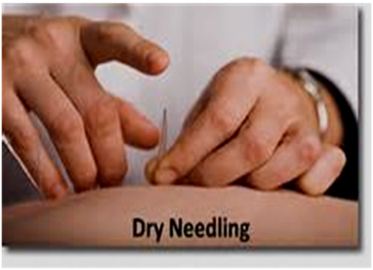
What are the risks of the procedure?
Though highly unlikely there are a few risks associated with this treatment. The most serious risk associated with TDN is accidental puncture of a lung (pneumothorax). If this were to occur, you might require a chest x-ray and no further treatment as it can resolve on its own. The symptoms of pain and shortness of breath may last for several days to weeks. A more severe lung puncture can require hospitalization and re-inflation of the lung. This is a rare complication and in skilled hands should not be a concern. Other risks may include bruising, infection, temporary nerve pain/injury, or short term internal bleeding. As the needles are very small and do not have a cutting edge, the likelihood of any significant tissue trauma from TDN is unlikely.
What does it feel like?
When a metal needle is inserted into fascial tissue that has collected electric potentiality, there is a discharge of electricity, similar to placing a metal object into a light socket. The amount of electricity is much less, of course, but the effect is the same. As the electricity is dispersed from the trigger point, it causes the muscle to slightly contract, just as though a normal signal of electricity had been sent from the central nervous system. This is called a 'local twitch response" and indicates the trigger point is releasing and the treatment will be effective. Patients often come to welcome this sensation.
Can my physical therapist perform it?
Trigger Point Dry Needling is a newer choice for holistic healing. Few MD's , and in certain states, Chiropractors have been allowed to utilize this awesome modality, but it's relatively new to the physical therapy world. About ten years ago, the Ohio Physical Therapy Association accepted this treatment option in our state. There are still some states in the US that do not allow physical therapist to perform it, but they are being hard pressed by the PT community to attain permission. The certification process is unique to each state, as far as required hours of training and testing procedures, but in general, a physical therapist must pay a price for this privilege. It is a costly course that involves intense study and a written and practical exam for certification. Some states require up to 200 hours of supervised training.
Is it the same as Acupuncture?
Unlike acupuncture, Trigger Point Dry Needling is aimed at releasing physical muscle tightness and neurological impulses that create trigger points. Its results are immediate and can cause a little soreness because your actually changing the physical tissue into a new shape and length, like molding clay. Acupuncture's goal is to open energy pathways and restore patterns of healing. This may take a few sessions to notice results and is generally painless. Both valid remedies for various conditions, just totally different in approach.

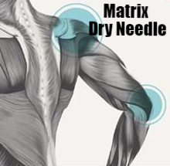
Matrixdryneedle.com

