Vibrational Medicine 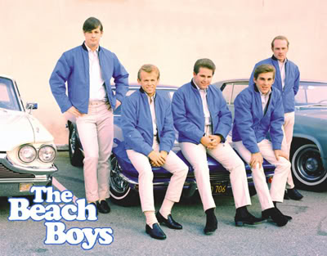
I wonder if the Beach Boys had any clue when they sang "I'm digging up
good vibrations, Wu, Wu, Wu, good vibrations," that they were delving into the light of quantum mechanics.
Albert Einstein spoke of vibrational forces inside all matter. He
stated everything is energy, and indicated, that the frequency at
which the molecules vibrate determines the state of that matter. For
instance, slowly vibrating molecules manifest as solid, faster
vibrations become liquid, then gas, sound, light, and so forth. All
colors and sounds vibrate to a frequency as well. Nothing sits idle.
In fact quantum physics describes the universe as nothing more than
vibrating strings of energy! Many of these frequencies were recorded
in ancient Egypt by Hermes Trismegistus.
We, also, now know that thoughts themselves can be classified as
energy forms and categorized according to their frequency. At
20-25,000 cycles per second (c/s), we get what's called ordinary human
awareness. It's a functioning level of consciousness for our day to
day thoughts, problem solving, analyzing, worry and fear. If we
operate at higher levels of consciousness, say 50-60,000 c/s, we
experience happiness, a deep inner peace and even bliss. It is
speculated the great spiritual masters of history were functioning at
a level of 80-90,000 c/s. People like Mother Teresa, Buddha, Lao Tzu,
Mother Meera of India, and Jesus himself performed miracles and
spontaneous healings at this level. The question is, can we, as
ordinary people, achieve these higher levels of vibration.
Ascended Master Saint Germain has said that, in truth, all one really
needs to do to change any aspect of their life, heal any dis-ease,
create abundance, or achieve Transfiguration of the physical body into
the Ascended Realm, is to raise their vibration and frequency.
Current research hypothesizes that every part of the body forms a
continuous interconnected bioenergetic communication network. Each
part of the body, even the smallest constituent, is vibrating to its
own rhythm. There is agreement among science, medicine and metaphysics
that certain frequencies can repel disease, and certain frequencies
can destroy disease. Herein lies the link between frequency
(vibration) and health. Using a quantum resonant magnetic analyzer,
scientific researchers have shown that different parts of our bodies
have their own sonic signature. When parts of the body become stressed
or dis-eased, they are no longer producing the correct sound wave or
frequency vibration. The key is getting back in tune.
One way to help align the frequencies of the body for healing is a new
therapy called Vibrational medicine. With the use of external devices,
such as a tuning fork or musical tones, this technique stimulates the
bioenergetics communication network, and the body's restorative systems
respond without the side-effects associated with the use of
pharmacological substances. There is now global interest and research
to show its validity. Vibrational Medicine, of which Homeopathy is a
part, has been used by various systems of medicine throughout the
ages, but because of its subtle nature, until recently it has been
largely ignored by the mainstream medical establishment. Fortunately,
this is no longer the case. Advancements in modern technology have
made it possible for the unseen/subtle to be seen. Researchers can now
view and measure the body's subtle energy fields, as well as changes
in these fields after Vibrational Medicine modalities have been
applied.
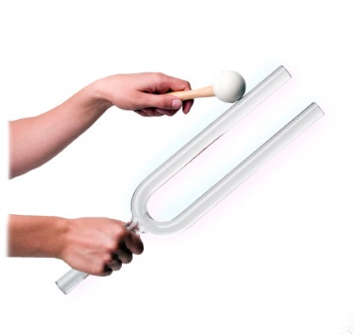
In 1925, Georges Lakhovsky published a paper expressing “the amplitude
of cell oscillations must reach a certain value, in order that the
organism be strong enough to repulse the destructive vibrations from
certain microbes.
The remedy in my opinion, is not to kill the microbes in contact with
the healthy cells but to reinforce the oscillations of the cell either
directly by reinforcing the radio activity of the blood or in
producing on the cells a direct action by means of the proper rays.”
The Multiwave Oscillator, that he designed, produced low frequency
radio waves with lots of “extremely short harmonics.” “The cells with
very weak vibrations, when placed in the field of multiple vibrations,
find their own frequency and start again to oscillate normally through
the phenomenon of resonance.”
Multiwave oscillators are claimed to strengthen cells within the body
to resist disease due to the principle that life forms absorb energy.
Other options of healing through vibration exist in nature.
Ultraviolet radiation from the sun, for example, helps support healthy
moods, brain function, endocrine system function and sleep cycles.
Sunlight photons also help us generate vitamin D, which prevents
cancer, diabetes, depression and bone loss. Infrared radiation has
been proven to speed recovery of wounds and injuries, and infrared LED
devices are being tested by NASA to speed the growth of plants in
space.
I will offer a few more methods to raise your frequency and attune
your vibration to health and wellness in my next article. In the
meantime, keep digging up those good vibrations.
"When a force in any organ or element of the body becomes deficient in
its ability to reproduce that equilibrium necessary for the sustenance
of physical existence and its reproduction, that portion becomes
deficient in electronic energy. This may come by injury or disease,
received by external forces. It may come from internal forces through
lack of eliminations produced in the system or by other agencies to
meet its requirements in the body."
Edgar Cayce (1928) from There is a River by Thomas Sugrue

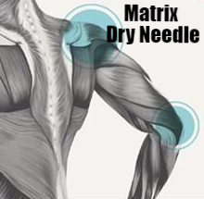
Matrixdryneedle.com

